How to load ART firmware
Load ART f/w by going to destination: M:\Engineering\Projects\XBee Wifi S6B\Atheros\XBee Flash OTP
Run xctu.cmd and load the firmware shown below.

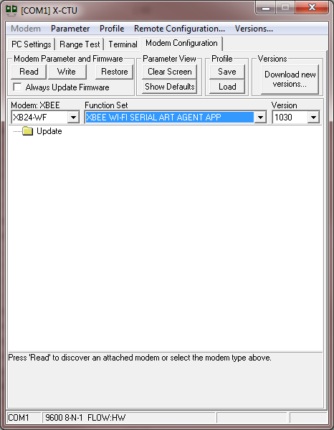
Click on always update firmware and then write. You might have to click write a few times until a message appears that says complete
If you are using a USB instead of an RS232 – do the following
Open device manager
Go to the device manager and double click on the device COM Port to open it
Go to the Port Settings Tab
Click Advanced
Lower the latency to the lowest setting (which is probably 1)

