Using XBee S6B “ART” test firmware
DIGI CONFIDENTIAL
- Unzip the artfiles.zip file directly on the C:\ drive.
- Connect device under test (DUT) to PC. Identify which COM port the DUT is connected to.
Note: if you use a USB to serial converter rather than a direct RS232 connection to your PC, you need to configure the serial port on your PC first to improve latency.
- Open device manager
- Under Ports, select the appropriate serial port. Right click and select Properties.
- Select the Port Settings tab and click Advanced.
- Change the USB transfer sizes, Receive and Transmit, to 64. Under BM Options change the latency timer to 1. Click OK.
- Open two explorer windows with the following paths:
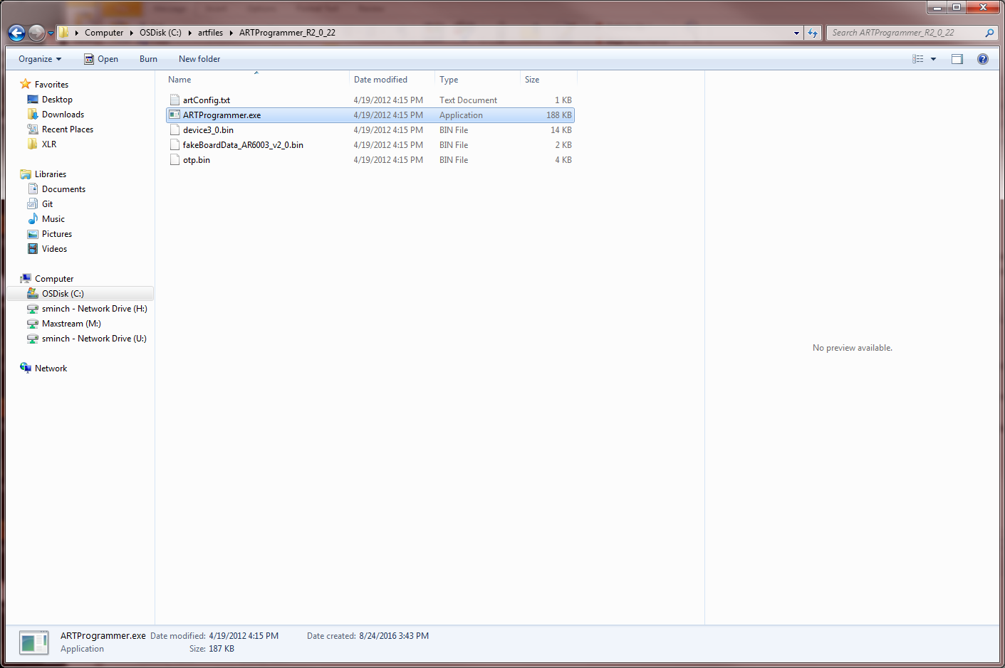
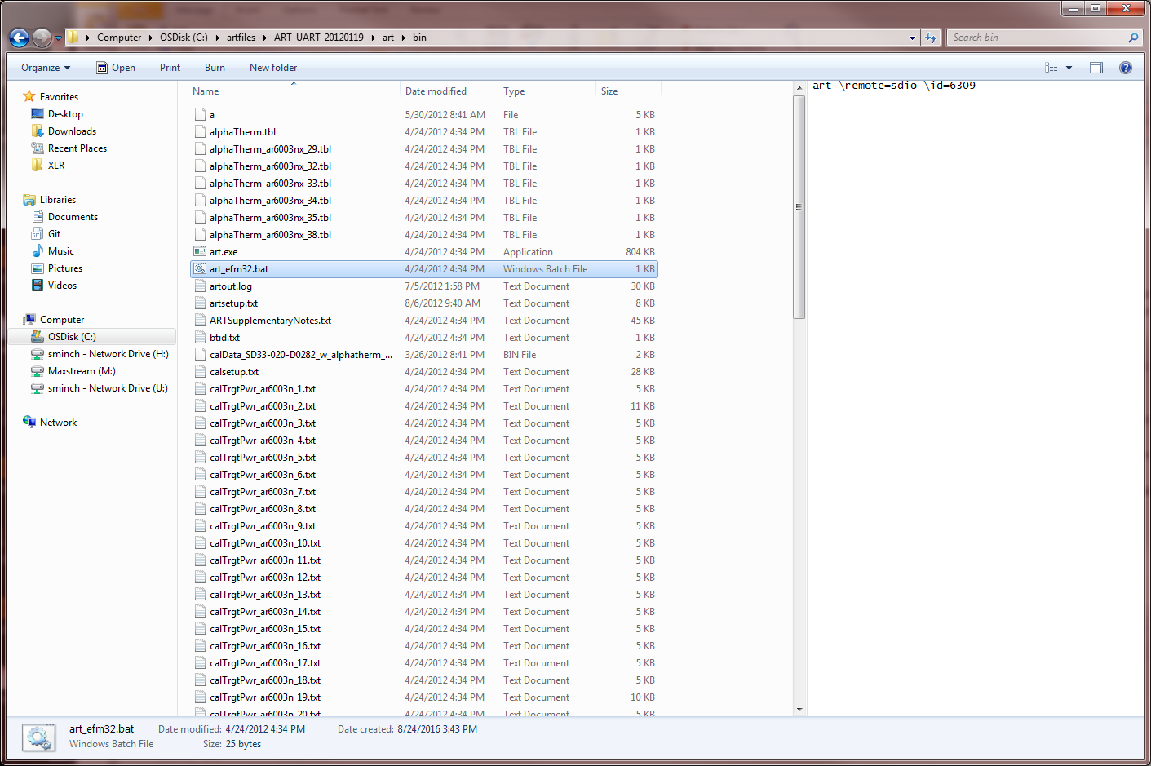
- Open remoteIP.ini found at C:\artfiles\ART_UART_20120119\art\bin\ and find the line that says: UART_PORT = \\.\COM1
Change the highlighted portion to match the COM port the device is connected to on your PC.
- In explorer window 1, double click ARTProgrammer.exe. The following screen will appear:
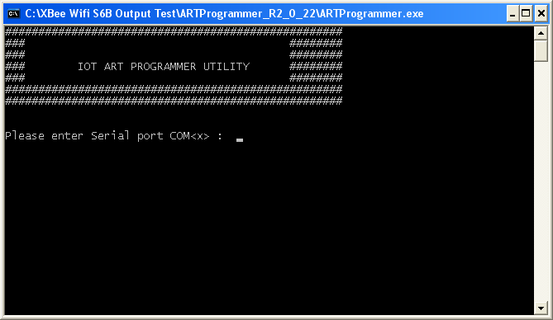
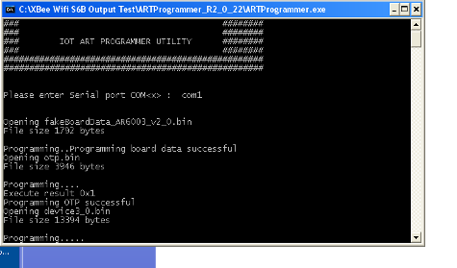

- Type “comX” where X is your serial port and press Enter. You should see a screen saying Programming….. that lasts for several seconds and then closes. If instead the window closes immediately, try resetting the device and try this step again.
- Once this window closes, go to explorer window 2 and double click art_efm32.bat. It should boot for several seconds and then give you the following screen (see the note below if this doesn’t work):
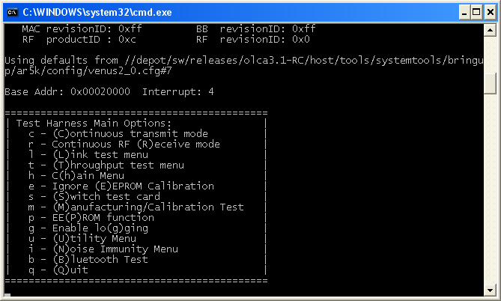
Note: We have found that this step sometimes returns an error on newer versions of Windows 7. The solution: right click on the art.exe file (NOT the batch file) and select Properties. On the Compatibility tab, check “Run this program in compatibility mode for…” and select Windows XP Service Pack 3.

Set test frequency
- Type ‘u’ to get to the utility menu, then press ‘c’ to change current channel value.
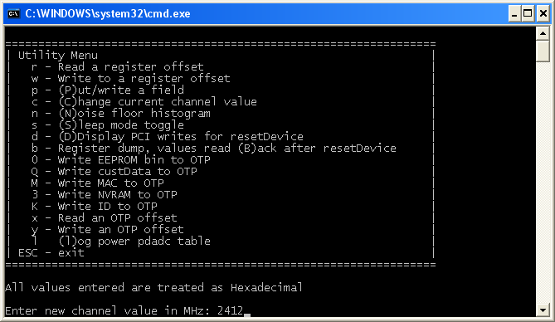
- Enter the channel value in MHz—I entered 2412, although it is by default on that channel at startup. Press Enter twice and then press Escape to get back to the main menu.

Transmit mode
- Press ‘c’ to start continuous transmit mode. Resize the window so it is bigger; this will make the screen appear more stable.
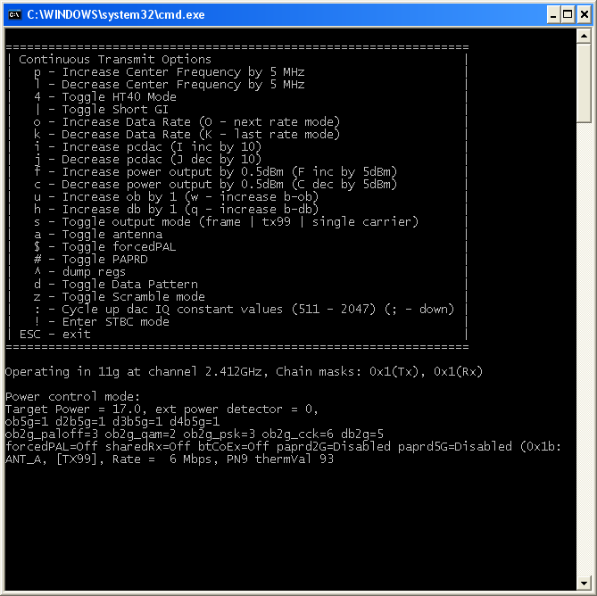
Data rate
Current frequency
Power setting

- The current state is shown in the lowest lines of text. See my descriptions in the figure above. Please note that the screen always says “Operating in 11g” even when it is in b and n modes. You can verify the mode it is in by the data rate (i.e. 1 Mbps is b mode).
- Whenever you type a key, you have to wait briefly for the screen to update.
- To change power level, type ‘f’ to go up 0.5 and ‘c’ to go down 0.5.
- To increase the data rate in the current mode (b, g, n), type ‘o’ (or ‘k’ to decrease). To change to a new mode, type ‘O’. The part is in G mode by default, then changes to B mode, then N mode. N mode is in 800ns guard interval by default. To change to 400ns, type the ‘|’ (vertical bar) key.
Note: in B mode the 2 Mbps and above cycle through “long” and “short” rates, but they are equivalent from an RF perspective. Just use long rate (e.g. 2 Mbps long).
- You can get back to the main menu by pressing “Esc”, which turns off the transmitter.
- Please note that there is an option to toggle HT40 mode. HT40 (40 MHz bandwidth) is not supported on the XBee so it does not need to be tested. HT20 (20 MHz bandwidth) is the supported bandwidth for n mode.
- If high temperature testing is required, please note that the part will periodically exit transmit mode because of overheating and take you back to the main menu. Wait a moment for the transmitter to cool, then re-enter transmit mode by pressing ‘c’. It will start transmitting again at the last data rate you set. This will not be an issue when testing at room temperature. Please note that the part is rated to a maximum temperature of 85C.

Receive mode
- Set the test frequency as shown previously.
- From the main menu (below), type ‘r’ to enter receive mode, as shown in the below picture.
- You can exit receive mode by pressing Esc.
